Project Design Phase-II

Data Flow Diagram & User Stories

|  |  |
| --- | --- |
| **Date** | **12 October 2022** |
| **Team ID** | **PNT2022TMID33575** |
| **Project Name** | **Natural disaster intensity analysis and**  **classification using Artificial intelligence** |
| **Maximum Marks** | **4 Marks** |

# Data Flow Diagrams:

Disasters caused by natural hazards are receiving increasing attention globally. They cause enormous casualties and huge economic losses, and adversely affect social stability.Simultaneously, social media popularity for sudden major disasters has also surged. Many individuals employ social media as an effective channel for timely accessible information in emergencies.

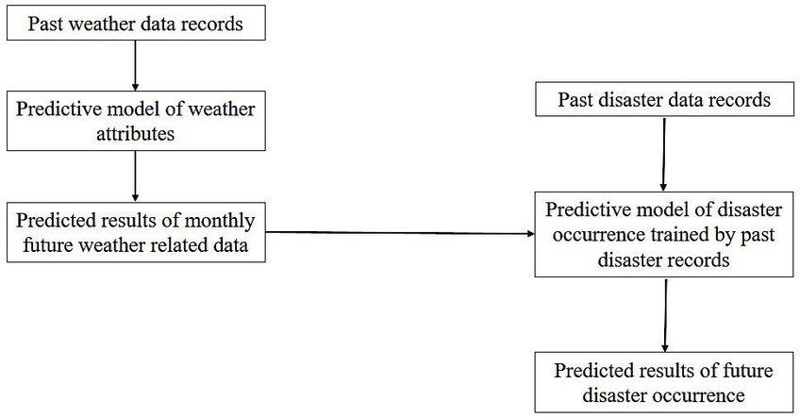

# User Stories

Use the below template to list all the user stories for the product.

|  |  |  |  |  |  |  |
| --- | --- | --- | --- | --- | --- | --- |
| **User Type** | **Functional Requirem ent (Epic)** | **User Story Numb er** | **User Story / Task** | **Acceptance criteria** | **Priorit y** | **Releas e** |
| Enduser (Customer)  ………… | preparedn ess | USN-1 | Proposed method can predict the  Short term spread the wildfire. | I can access the proposed method of  wildfire. | High | Sprint- 1 |
| Enduser  (Customer) | Mitigation | USN-2 | Develop a public platform to  inform early tsunami prediction and information. | Public feedback  is compulsory for the prediction process. | Low | Sprint- 1 |
| Enduser\ (Customer) | Random forest | USN-3 | Evaluate the flood severity in  terms of sensitivity, specificity and accuracy as 71.4% respectively. | Particle swarm  optimization and deep learning techniques can be used as a framework. | High | Sprint- 2 |
| Enduser  (Customer) | Recovery | USN-4 | Prediction occurs in the past  dataset to recover the natural disaster issue. | Dynamic time  series data required for clustering process. | High | Sprint- 1 |
| Enduser  (Customer) | Machine  learning techniques | USN-5 | The gradient boosting tree  and CLIPPER model used for cyclone prediction. | Model is still  weak to produce velocity sensitivities. | Low | Sprint- 2 |
| Enduser (Customer) | Artificial neural network | USN-6 | A fully connected neural  network for segmentation which is used for multivariable pattern recognition at different levels. | It works on  multivariable parameters rather than the pixel by parameters. | High | sprint-1 |
| Enduser  (Customer) | Update  Disaster information | USN-7 | As an administrator, I can  update information about disasters. | I can update  disaster information. | High | sprint-1 |
| Enduser  (Customer) | Disaster  queries | USN–8 | Both are can able to ask  disaster queries | We can ask  queries about disasters. | High | sprint-1 |